|  |
| --- |
| BTS430 |
| Partial  Requirements Document |
| **Group 11** |

|  |
| --- |
| Created By: Group 11 |
| Person 1: Khai Phan |
| Person 2: Adrian Recchi |
| Person 3: Ori Schapiro |
| Person 4: Eden Tunutu |

**Table of Content**

1 Create Promotion by Khai Phan 3

1.1 Business process name: 3

1.2 System Use Case Diagram for Create Promotion 3

1.3 Use Case Descriptions for a set of CRUD 3

1.3.1 Use Case 1: Apply for promotion 3

1.3.2 Use Case 2: Purchase department review promotions details 3

1.3.3 Use Case 3: Sale department apply change to current product 3

2 Request for absence/leave by Eden Jeremiah Tunutu 3

2.1 Business process name: Request for absence/leave 3

2.2 System Use Case Diagram for business process 1 3

2.3 Use Case Descriptions for a set of CRUD 3

2.3.1 Use Case 1: Request leave 3

2.3.2 Use Case 2:  Review absence request 3

2.3.3 Use Case 3: Update Schedule 3

3 Business Process 2 by Ori Schapiro 3

3.1 Business process name: Return Product 3

3.2 System Use Case Diagram for business process 1 3

3.3 Use Case Descriptions for a set of CRUD 3

3.3.1 Use Case 1: (Request Refund) 3

3.3.2 Use Case 2: (Refund Item) 3

4 Business Process 1 by (student name) 3

4.1 Business process name: 3

4.2 System Use Case Diagram for business process 1 3

4.3 Use Case Descriptions for a set of CRUD 3

4.3.1 Use Case 1: (name of use case) 3

4.3.2 Use Case 2: (name of use case) 3

4.3.3 Use Case 3: (name of use case) 3

4.3.4 Use Case 3: (name of use case) 3

# **Business Process** 5 **by Khai Phan**

## **Business process name:** Promote **Product**

## **System Use Case Diagram for Business Process** 5

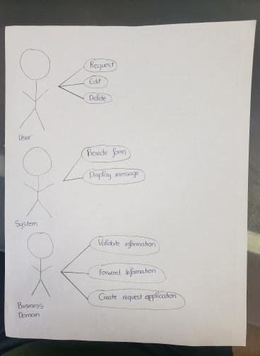

## **System Use Cases for a set of CRUD**

## **System Use Case 1: Return Product**

#### **Main flow description:**

|  |  |  |  |  |
| --- | --- | --- | --- | --- |
| Step# | Promoter | UI Display | Business Domain’s action | Database Interaction |
| 0 |  | Promote Product |  |  |
| 1 | Request to Promote product | Request for product SKU number | Create a new Promotion application |  |
| 2 | Provide SKU number | Display product details | Validates SKU number |  |
| 3 | Provide promotion length and detail | Request promotion details | Validates all information | Displaying example of new product promotion |
| 4 | Confirm product promotion | Display message update | Forward information to Purchase department |  |

#### **System Sequence Diagram**

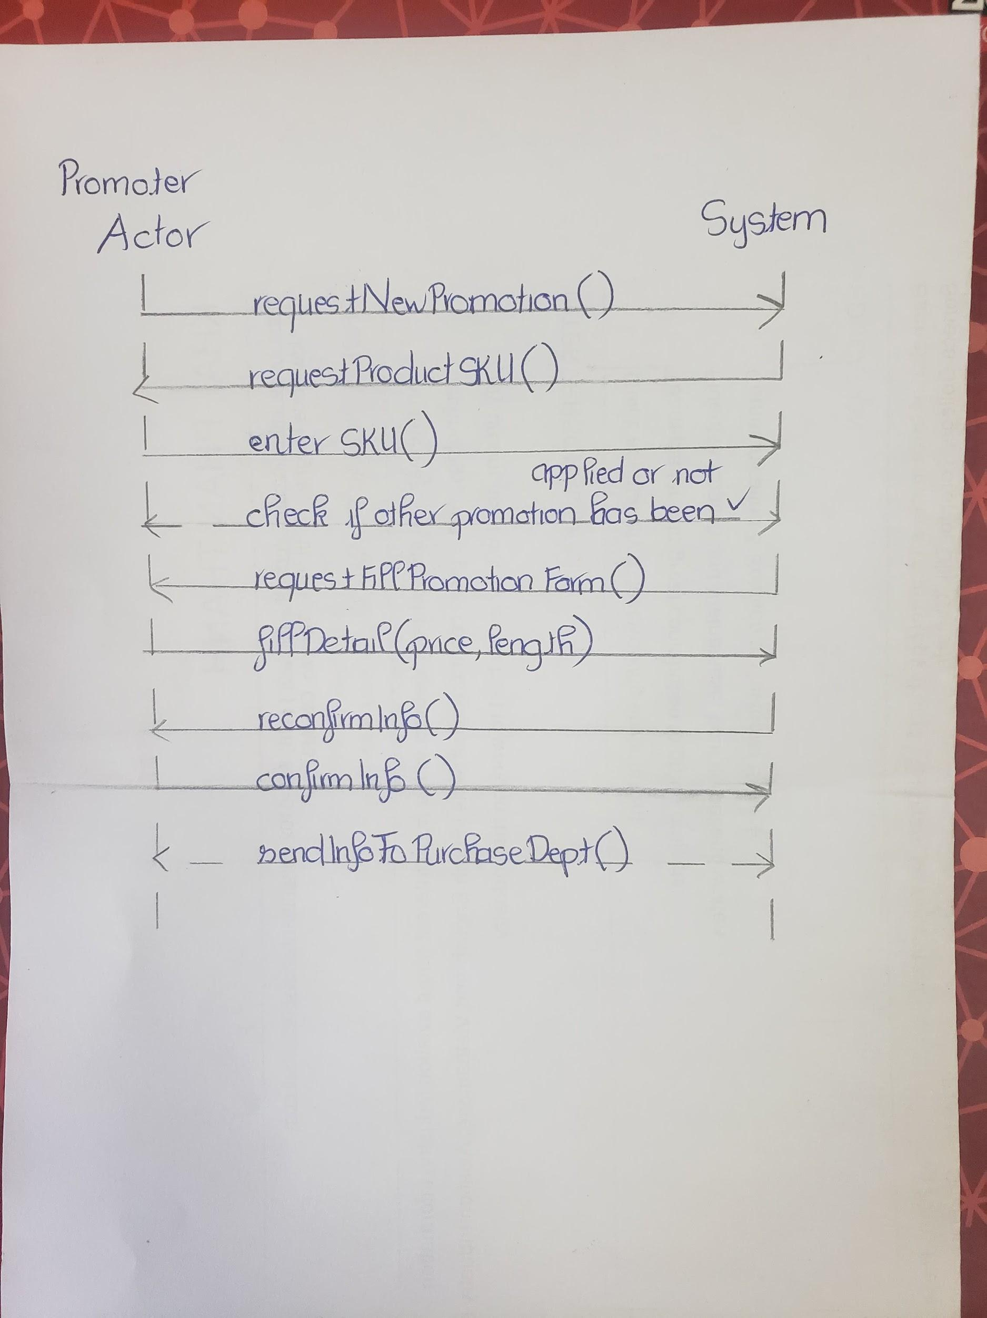

## **System Use Case 2: (name of use case)**

#### Main flow description:

|  |  |  |  |  |
| --- | --- | --- | --- | --- |
| Step# | Purchase Department | UI Display | Business Domain’s action | Database Interaction |
| 0 | Check for waiting promotion | Display waiting promotion notification |  | Retrieve corresponding product information |
| 1 | Check for promotion details | Request to confirm promotion detail |  |  |
| 2 | Confirm Promotion details | Display confirm message | Forward information to Sales Department |  |

#### System Sequence Diagram

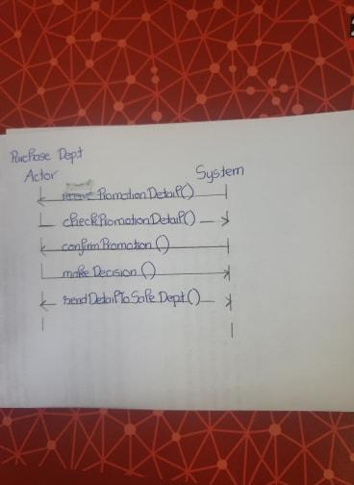

## **System Use Case 3: (name of use case)**

#### Main flow description:

|  |  |  |  |  |
| --- | --- | --- | --- | --- |
| Step# | Sale Department | UI Display | Business Domain’s action | Database Interaction |
| 0 | Check for waiting promotion | Display waiting promotion notification |  | Retrieve corresponding product information |
| 1 | Create a new promotion to the product | Request to confirm changes finished |  | Override promotion detail to current product detail |
| 2 | Confirm promotion has been applied | Display success message |  |  |
| 3 |  |  |  |  |

#### System Sequence Diagram

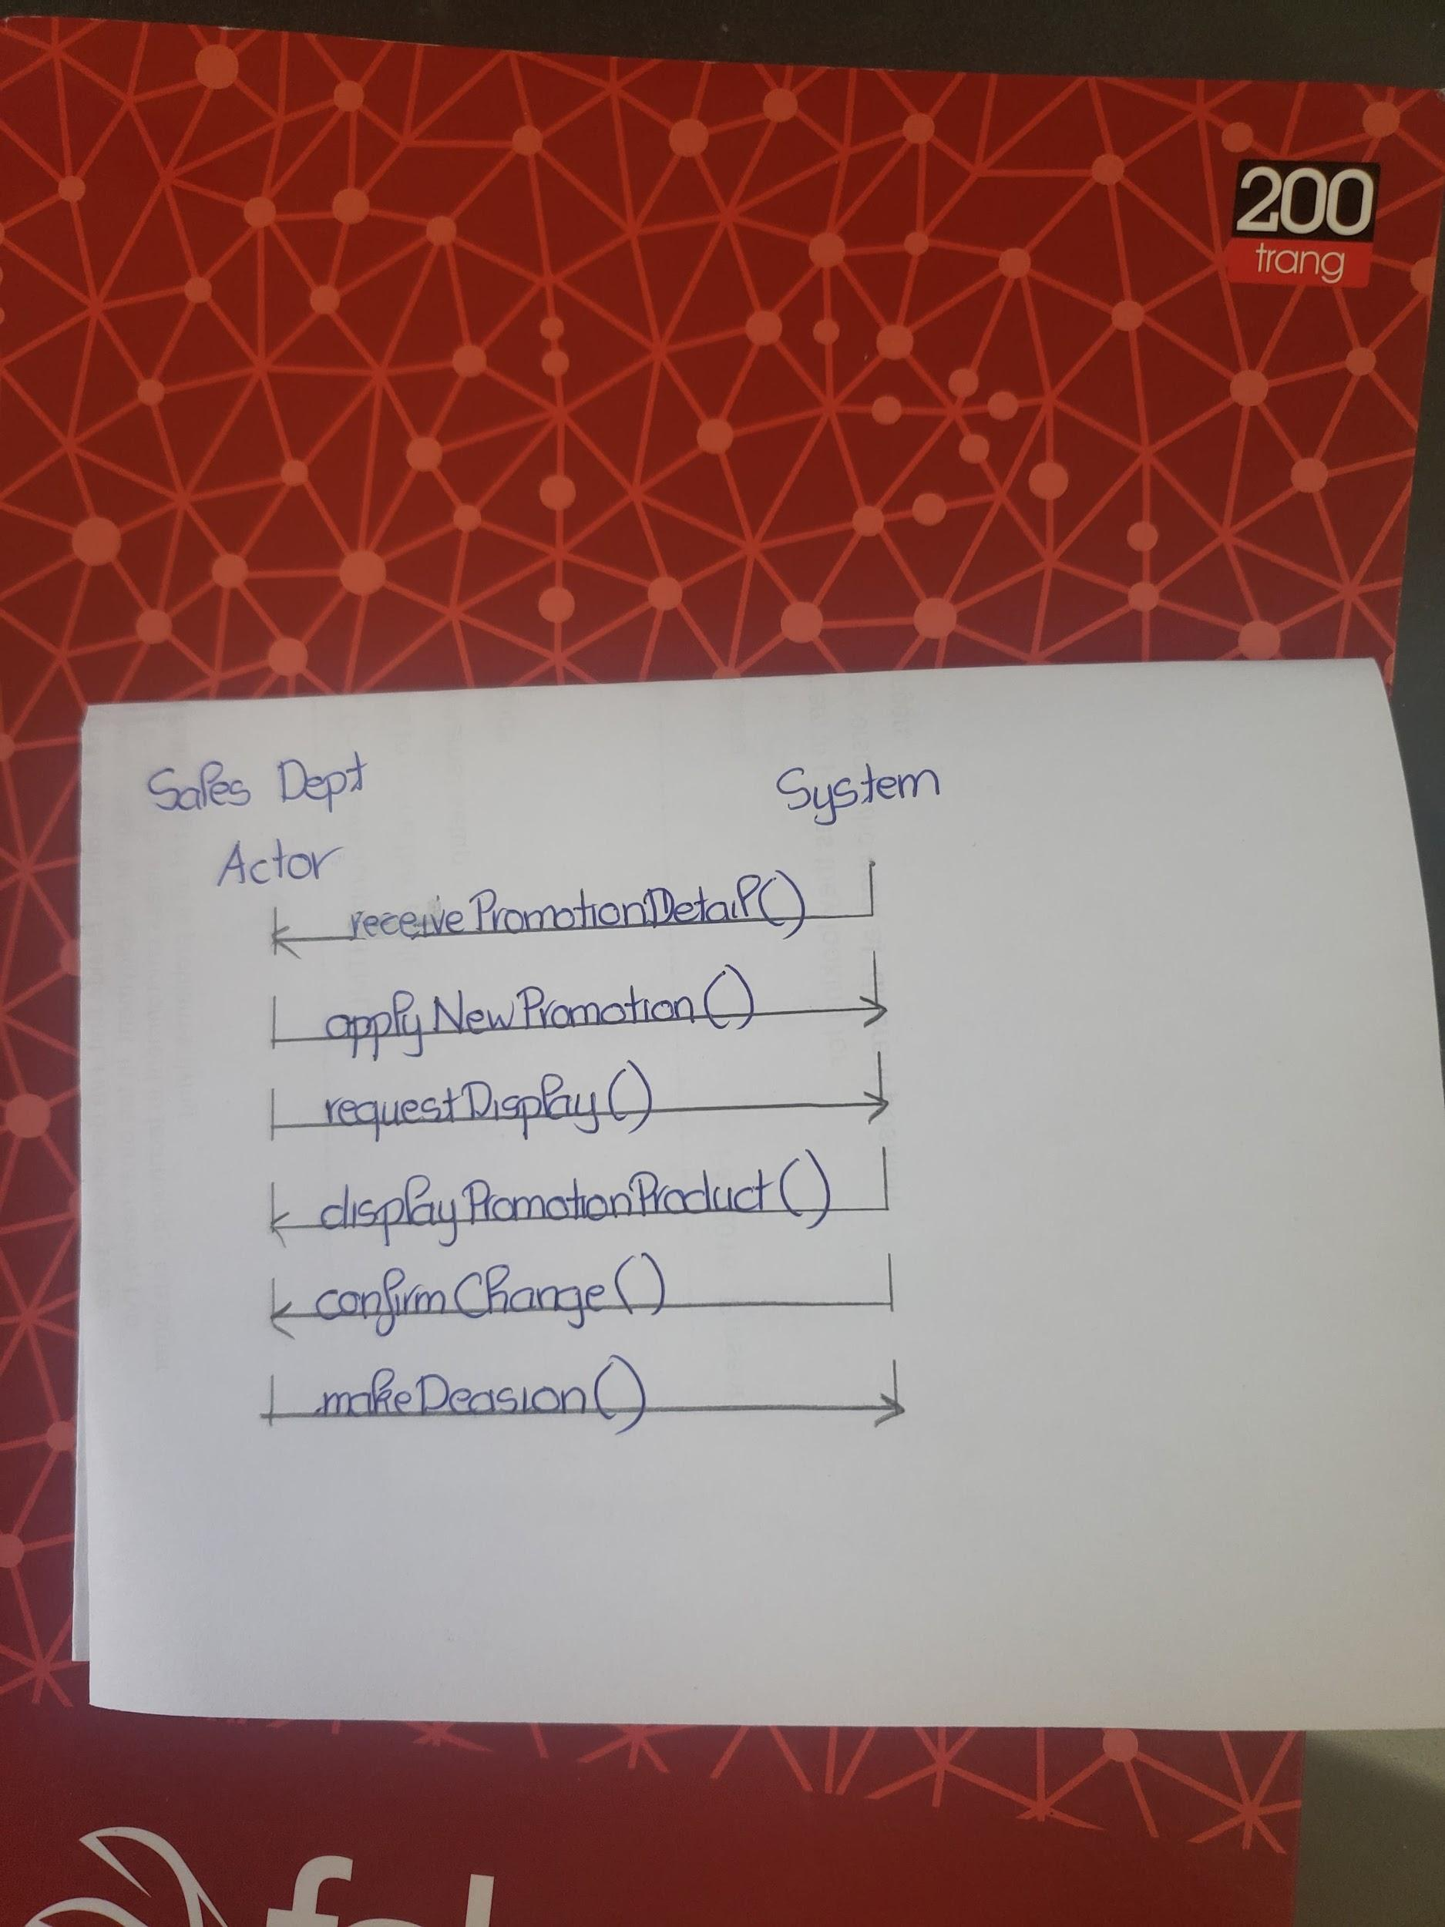

## **Class Diagram from your CRUD**



# **Business Process** 4by Eden Jeremiah Tunutu

## **Business process name:** Request for absence/leave

## **System Use Case Diagram for business process 1**

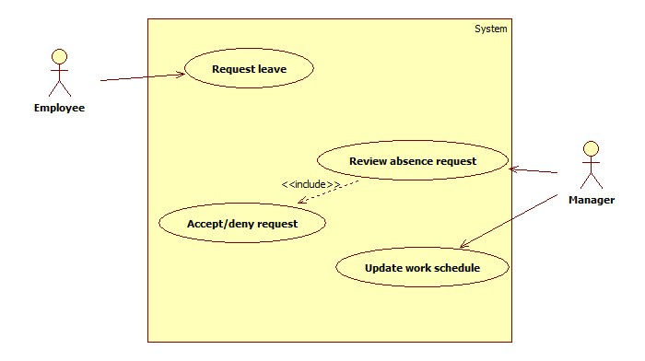

## **System Use Cases for a set of CRUD**

## **System Use Case 1:** Request leave

#### **Main flow description:**

|  |  |  |  |  |
| --- | --- | --- | --- | --- |
| Step# | Employee | UI Display | Business Domain’s action | Database Interaction |
| 0 |  | Button: Request time off |  |  |
| 1 | Request to take time off | Request for date and time for day-off(selection field for date and time and full day or partial day off Time is optional if partial day ) | Create new day-off request |  |
| 2 | Provide date and time within 3 months | Display date and time provided | Validate date and time is within 3 months |  |
| 3 | Confirm date and time | Ask for confirmation of date and time |  |  |
| 4 | Send request | Display success message | Alert manager of request via email | Save request with all information |

#### **System Sequence Diagram**

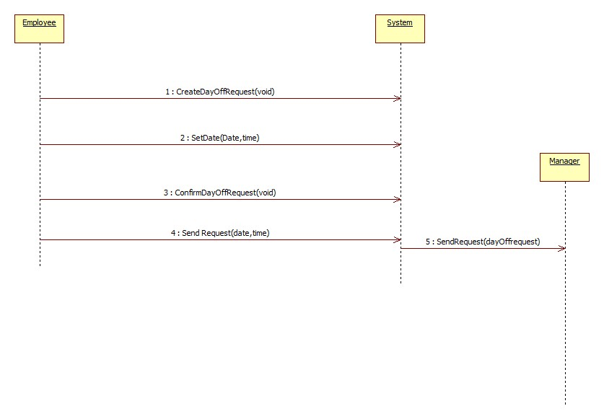

## **System Use Case 2:** Review Absence Request

#### Main flow description:

|  |  |  |  |  |
| --- | --- | --- | --- | --- |
| Step# | Manager | UI Display | Business Domain’s action | Database Interaction |
| 0 |  | Button: Day off requests |  |  |
| 1 | Request to view all absence/day off requests | Show all day off requests | Provide day off requests | Fetch all day-off requests |
| 2 | Accept /deny request according to availability |  | Set status of request to approved/denied |  |
| 3 | Confirm approval/denial status | Show confirmation message |  | Store the approved requests |
| 4 | Repeat above step for all requests |  |  |  |

#### System Sequence Diagram

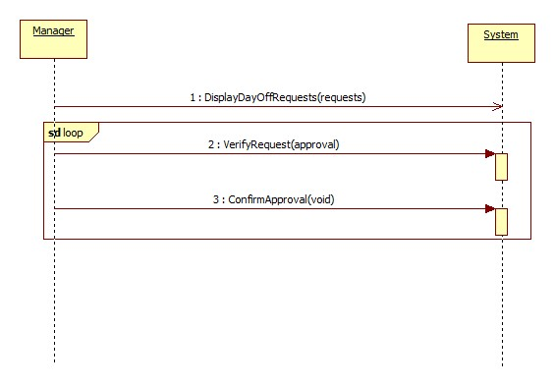

## **System Use Case 3:** UPDATE SCHEDULE

#### Main flow description:

|  |  |  |  |  |
| --- | --- | --- | --- | --- |
| Step# | Manager | UI Display | Business Domain’s action | Database Interaction |
| 0 |  | Display Current Schedule (read only version) |  |  |
| 1. | Request to update schedule in time period (day,week or month) | Display current  schedule (update version) |  | Verify employee has access |
| 2. | Find employees with approved requests | Show employees with approved requests |  | Fetch all approved requests |
| 3. | Remove employee from schedule | Show confirmation message for removal | Delete employee from the schedule |  |
| 4. | Repeat above for all employees with approved request |  |  |  |
| 5. | Post new schedule | Show success message | Email all employees new schedule | Store new schedule and delete old one |

#### System Sequence Diagram

## **Class Diagram from your CRUD**

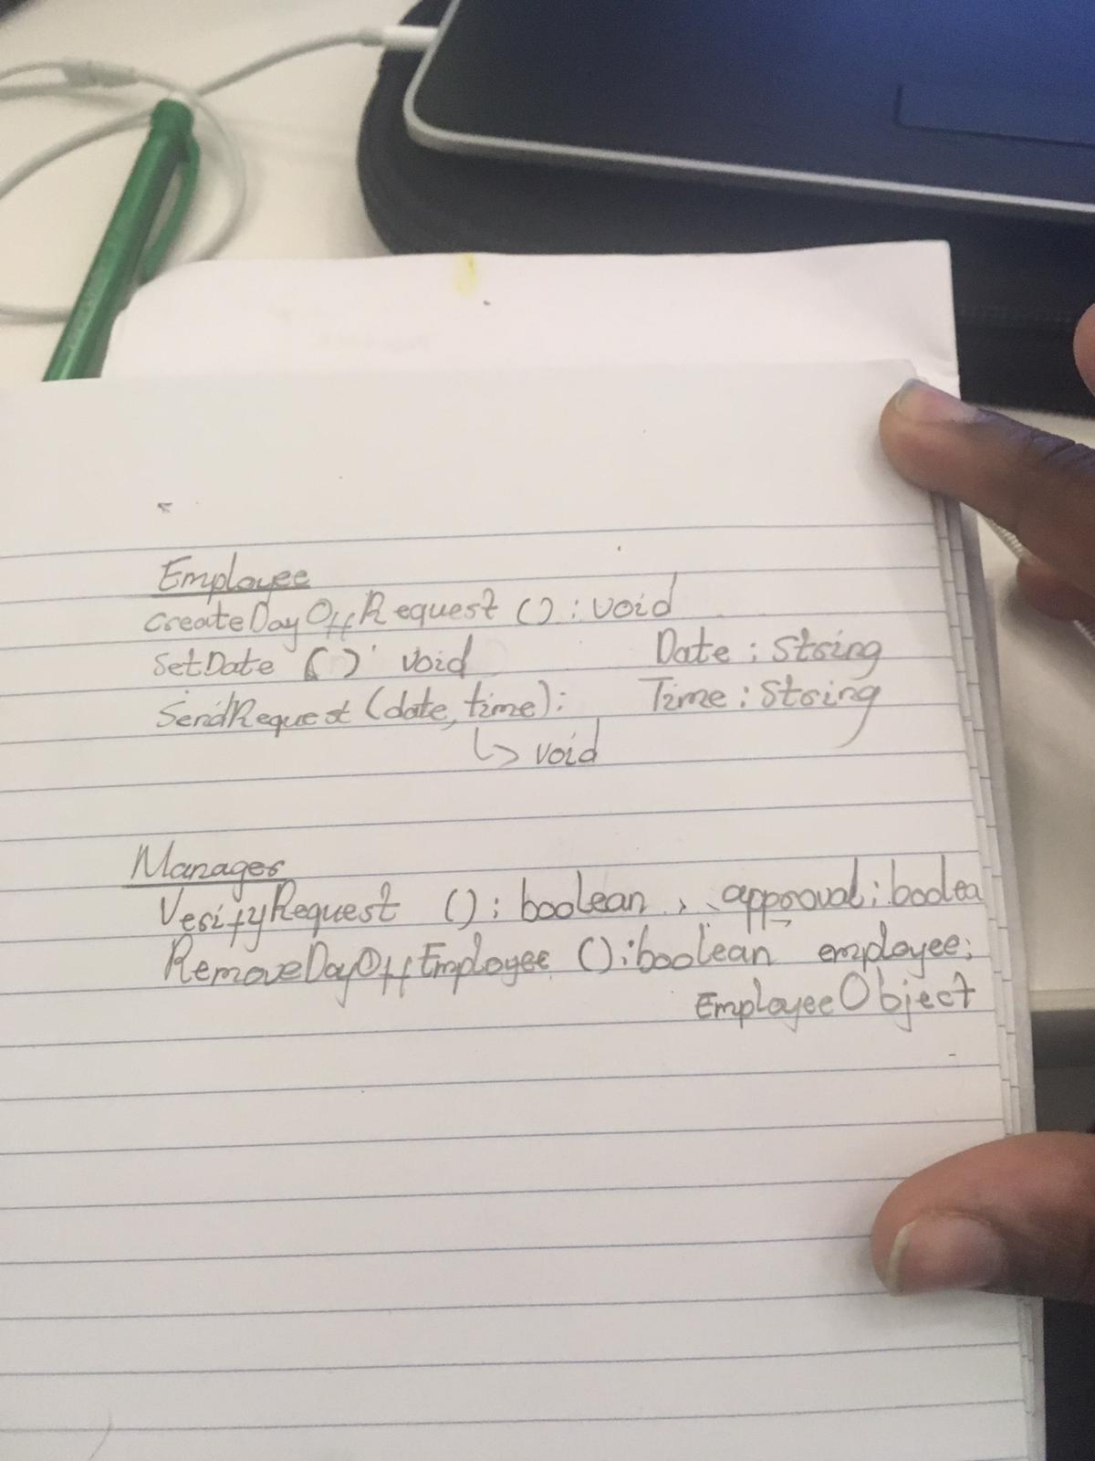

# **Business Process** 2 **by** Ori Schapiro

## **Business process name: (Return Product)**

## **System Use Case Diagram for business process** 2

Put your system use case diagram here

## **System Use Cases for a set of CRUD**

## **System Use Case 1: (**Request Refund**)**

#### **Main flow description:**

|  |  |  |  |  |
| --- | --- | --- | --- | --- |
| Step# | Actor’s action | UI Display | Business Domain’s action | Database Interaction |
| 0 |  | Button: Request Product Refund |  |  |
| 1 | Request refund for product | Request for Receipt  (entry field for receipt#) | Create a refund template |  |
| 2 | Provide Receipt Information | Request for Previously Used Payment Information (entry field for credit card#, name on card, expiry date, cvv) | Validate Receipt and Link Receipt to refund template | Retrieve Receipt Information |
| 3 | Provide Credit Card Information | Display Receipt Information (Receipt #, Date Purchased, list of Items purchased, Amount Spent) | Validate that Credit Card Information provided matches Receipt |  |
| 4 | Confirm Correct Receipt | Display Items from list to be refunded |  |  |
| 5 | Select Item to be refunded | Request confirmation to Refund Selection |  |  |
| 6 | Confirm Refund Selection | Display Refund Ticket created Successfully. Display shipping information that the customer must ship the returned Item to. Display instructions to ensure customer provides Receipt/copy of Receipt to be shipped with the product. | Link Item to Be Refunded to refund template | Save refund template with all information |

#### **System Sequence Diagram**

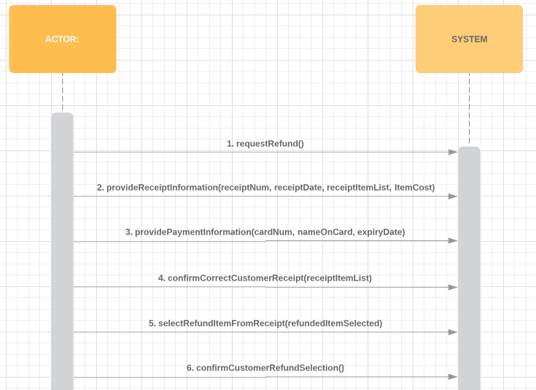

## **System Use Case 2: (Refund Product)**

|  |  |  |  |  |
| --- | --- | --- | --- | --- |
| Step# | Actor’s action | UI Display | Business Domain’s action | Database Interaction |
| 0 |  | Button: Process Item to be Refunded |  |  |
| 1 | Request to Process Item for Refunding | Request for Receipt Information (entry field for receipt#) |  |  |
| 2 | Provide receipt information | Display Refund information (item to be refunded) | Validate Receipt by comparing to refund template | Retrieve refund template |
| 3 | Confirm Correct Refund Information | Display Refund Successful | Process Payment | Update Refund Template as complete |

#### System Sequence Diagram

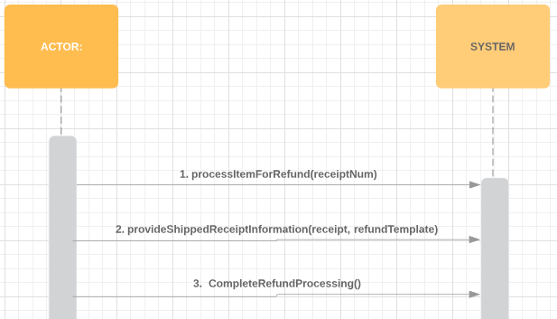

## **Class Diagram from your CRUD**

# **Business Process** 3 **by** Adrian Recchi

## **Business process name: Hire Employee**

## **System Use Case Diagram for business process** 3

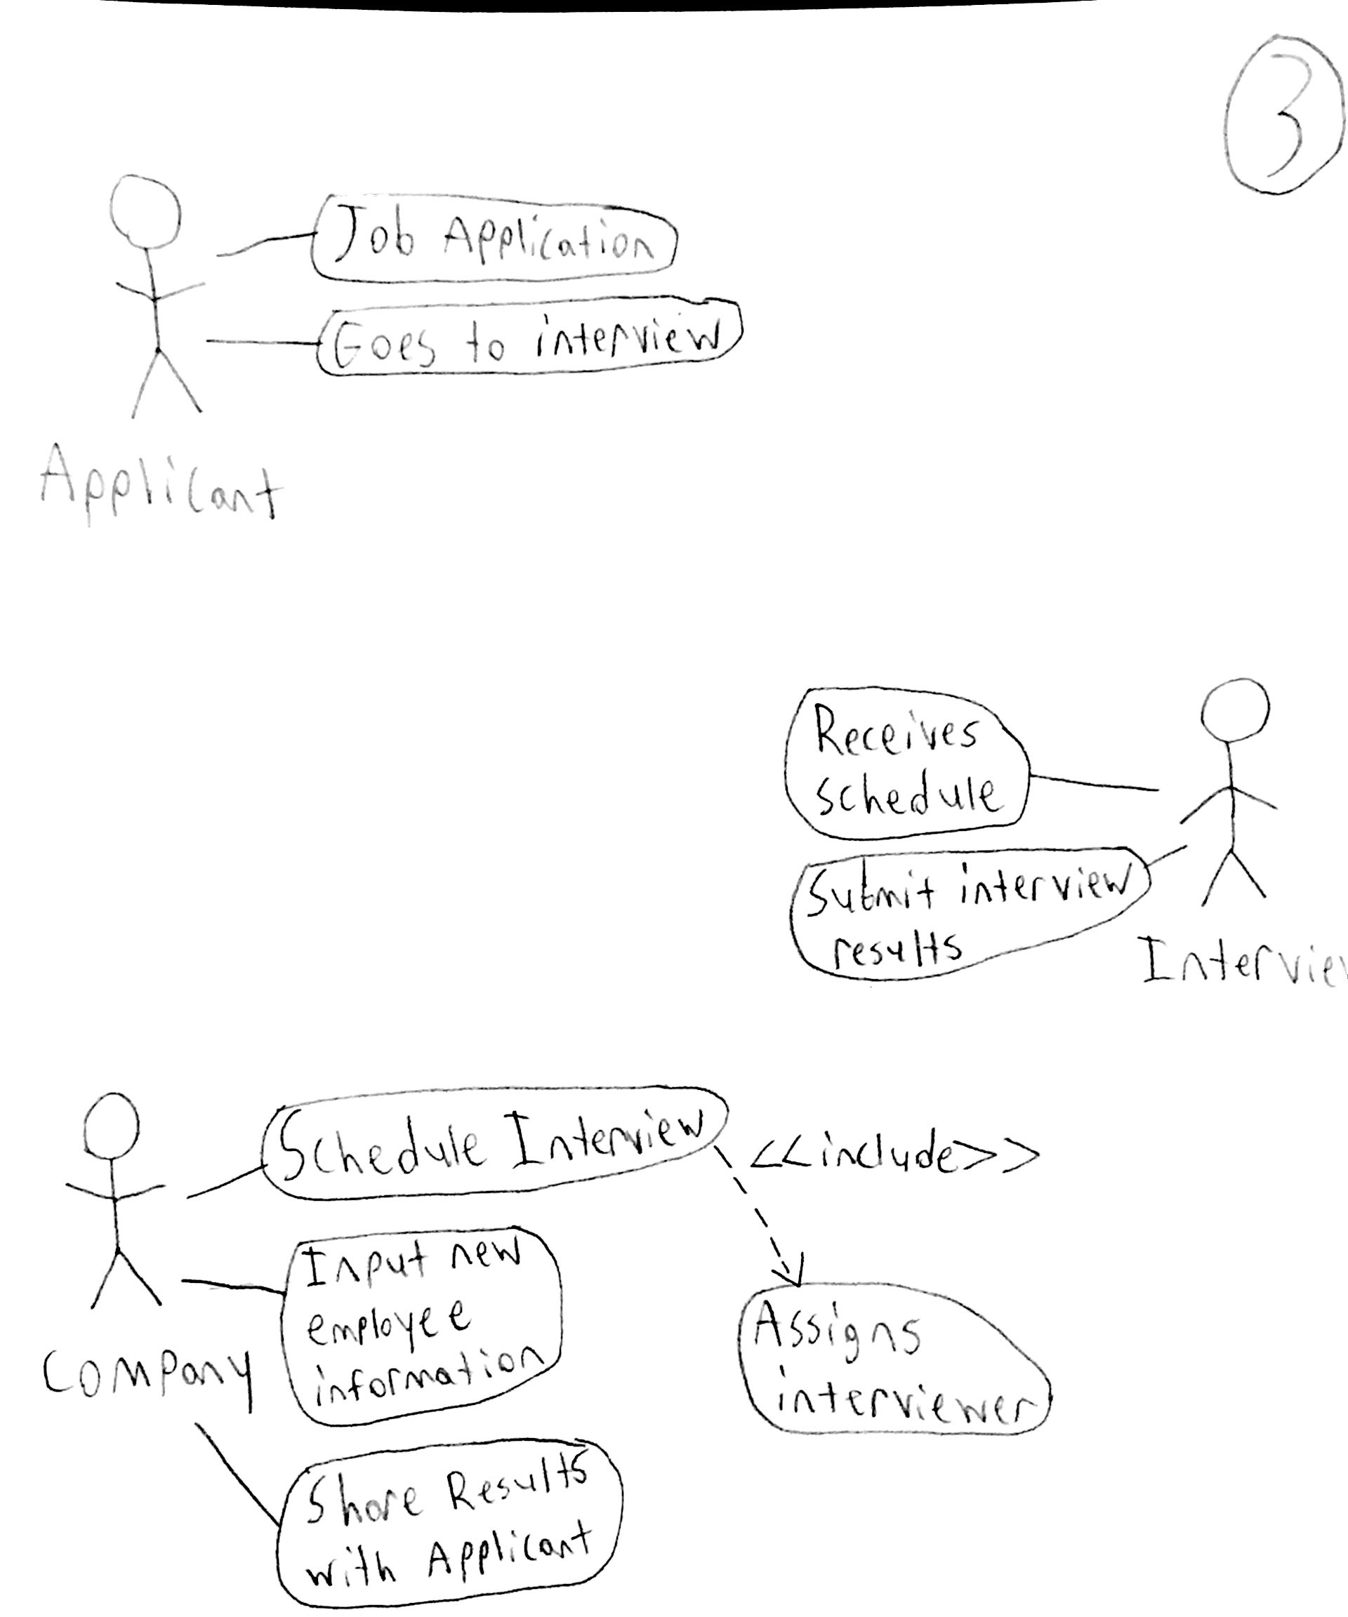

## **System Use Cases for a set of CRUD**

## **System Use Case 1:** Schedule Interview

#### **Main flow description:**

|  |  |  |  |  |  |
| --- | --- | --- | --- | --- | --- |
| Step# |  | Actor’s action | UI Display | Business Domain’s action | Database Interaction |
| 0 |  |  | Button: Apply for position |  |  |
| 1 |  | Request to apply for a job opening | Displays available positions |  |  |
| 2 |  | Selects a position | Displays position information and asks for resume attachment |  |  |
| 3 |  | Opens resume document | Displays resume on screen and asks for confirmation | Attaches resume to page |  |
| 4 |  | Confirm application | Displays that application has been received |  | Records application to database records |

#### **System Sequence Diagram**

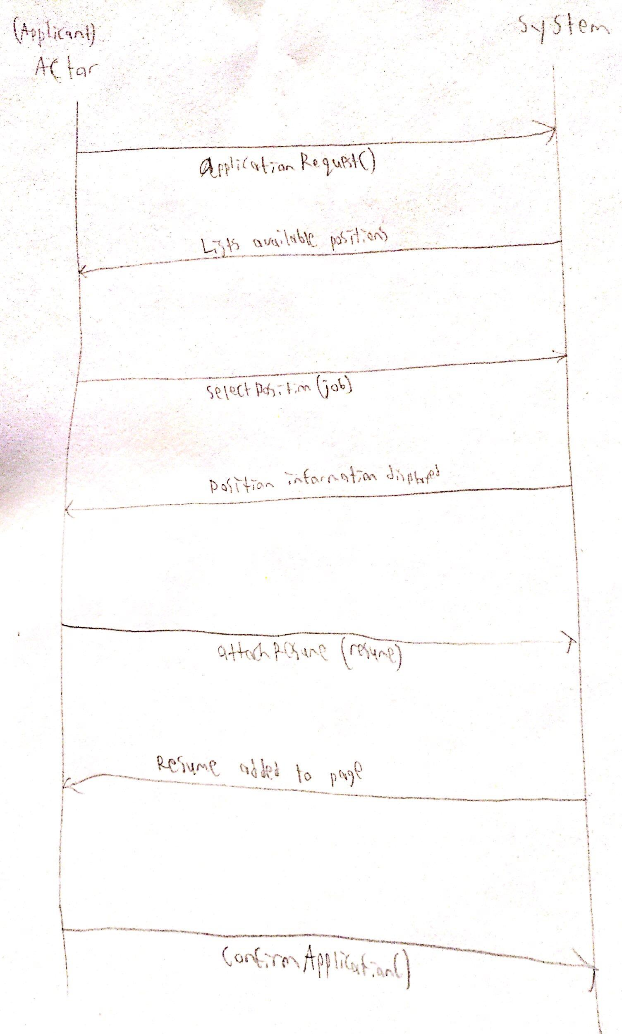

## **System Use Case 2:** Submit Interview Result

#### Main flow description:

|  |  |  |  |  |  |
| --- | --- | --- | --- | --- | --- |
| Step# |  | Actor’s action | UI Display | Business Domain’s action | Database Interaction |
| 0 |  |  | Button: Update interview result |  |  |
| 1 |  | Request to update applicant status | Displays applicant information |  | Retrieve applicant credentials |
| 2 |  | Choose “hired” status | Ask to confirm choice |  |  |
| 3 |  | Confirm result | Displays successful changes have been made | Changes applicant status to “hired” |  |

#### System Sequence Diagram

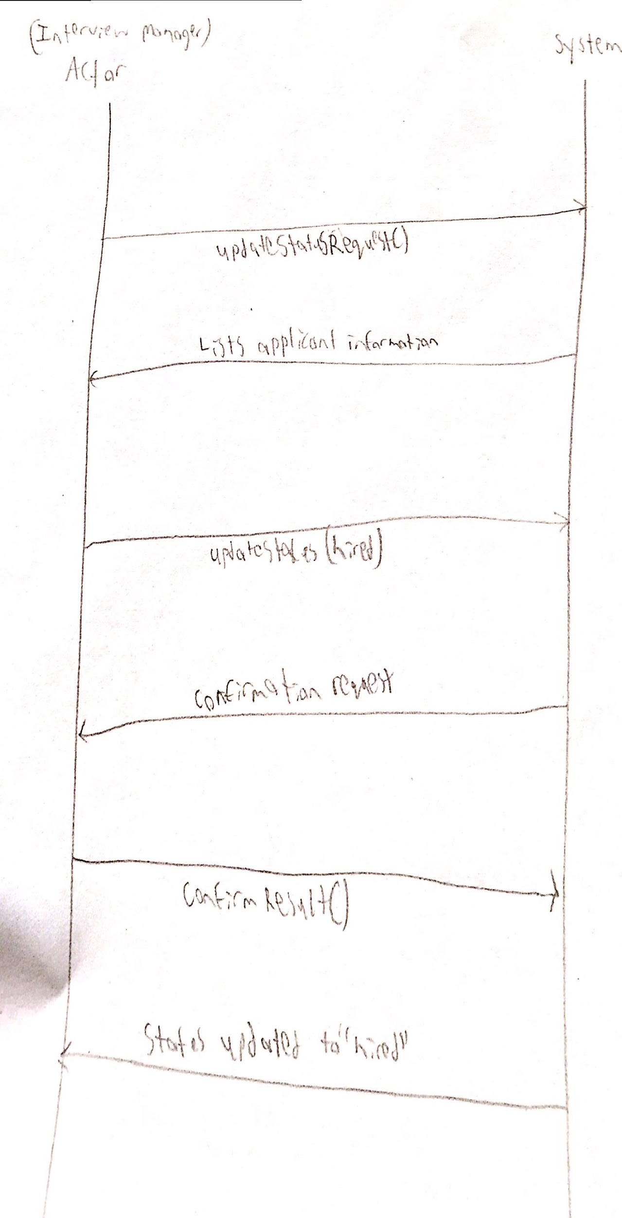

## **System Use Case 3:** Register New Employee Data

#### Main flow description:

|  |  |  |  |  |  |
| --- | --- | --- | --- | --- | --- |
| Step# |  | Actor’s action | UI Display | Business Domain’s action | Database Interaction |
| 0 |  |  | Button: Add new employee to company |  |  |
| 1 |  | Request to add new employee | Request employee credentials |  |  |
| 2 |  | Provides employee information | Ask for confirmation of employee entry | Set employee information |  |
| 3 |  | Confirms new employee addition | Displays successful employee addition |  | Record employee information |

#### System Sequence Diagram

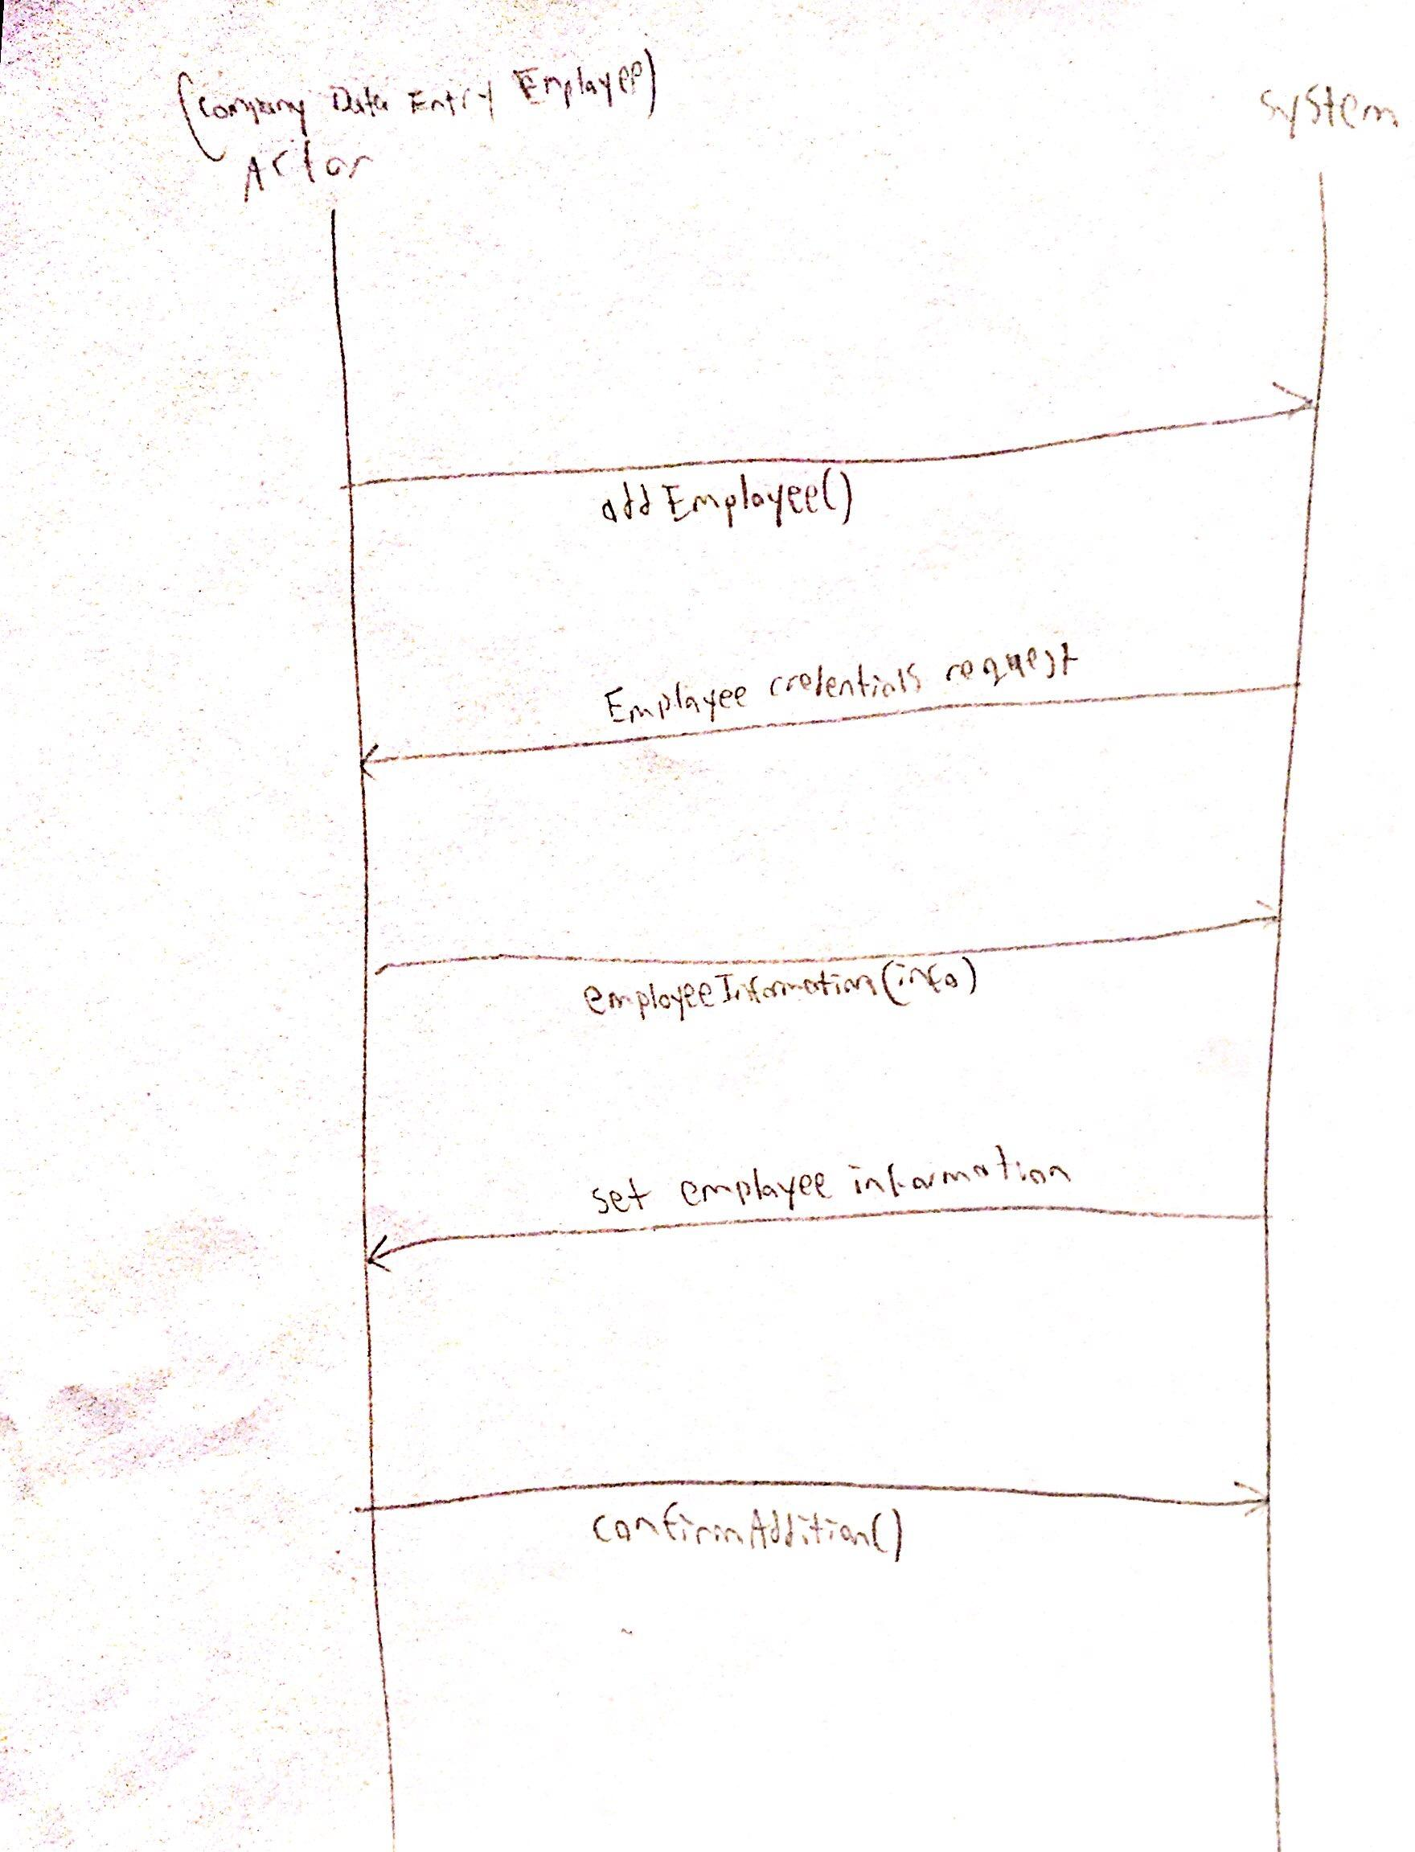

## **Class Diagram from your CRUD**

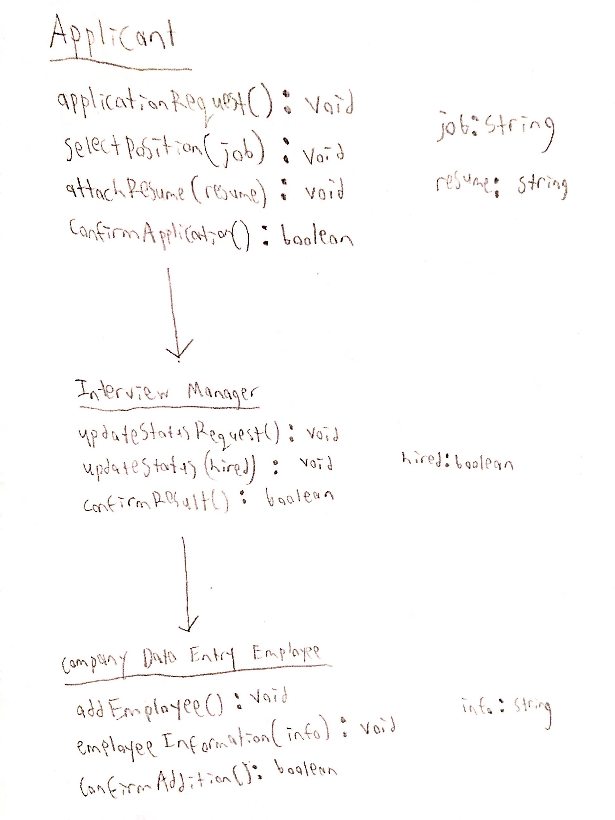

# **Synchronized Class diagram from all group members**

**************

### **Example of SUC Main Flow:**

|  |  |  |  |  |
| --- | --- | --- | --- | --- |
| Step# | Actor’s action | UI Display | Business Domain’s action | Database Interaction |
| 0 |  | Button: Book Road Test |  |  |
| 1 | Request to book road test | Request for driver’s license (entry field for driver license#, DoB) | Creates a new road test appointment |  |
| 2 | Provide driver’s license | Displays driver’s information, asks for confirmation for the driver | Validates driver’s license# and DoB | Retrieve driver’s information |
| 3 | Confirm driver | Displays available dates/times for appointments | Link the driver to the appointment | Retrieve available date/times |
| 4 | Choose date/time | Asks for confirmation of date/time |  |  |
| 5 | Confirm date/time | Asks for credit card infor for payment (credit card#, name on card, expiry date, cvv), displays default billing address. | Set data/time to the appointment |  |
| 6 | Provide credit card infor; keep/modify billing address | Asks for confirmation of payment. | Validate credit card information. | Save appointment with all information |
| 7 | Confirm payment | Displays successful booking. | Process payment |  |